4.1 TMA Themes Changes

Create new Themes and Asset Type
- Run the GIS Layer Tool (GOS0020)
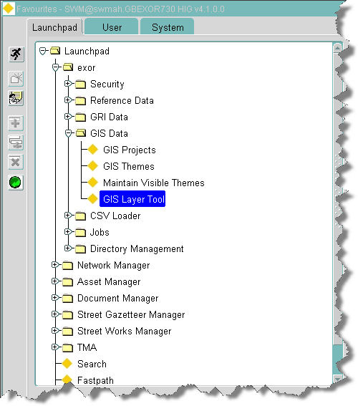
- Click on TMA Layers under Traffic Management Act
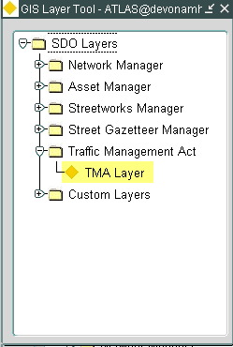

- Make sure the top check box (Phase is checked).
- Click on [Get Themes] button. This will populate the bottom grid if it is not populated already.
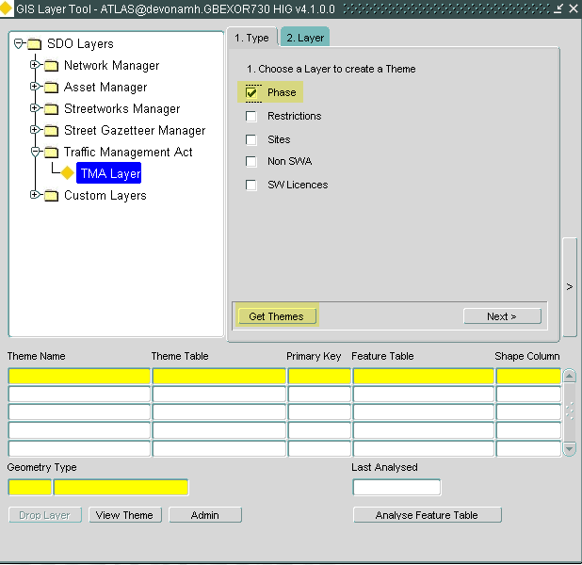

- Make a note of the Theme Name for the feature table V_TMA_PHASES_SDO. In this case it is TMA_ACTIVE_PHASES.
- Click on the next button.
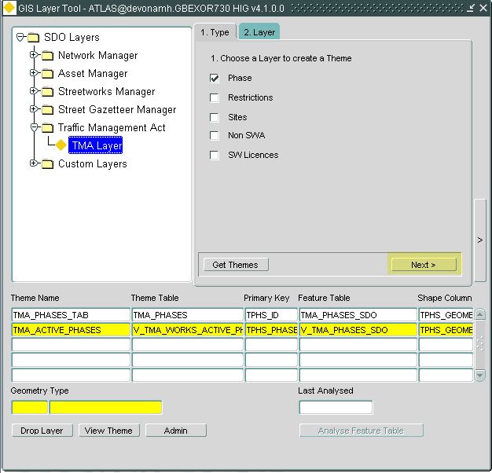

- Put the name of the theme in the top text box
- Set Asset type to TMAP and asset type to TMA ACTIVE PHASES. N.B. if this is already set do not change.
- Click on [Refresh Layer] button
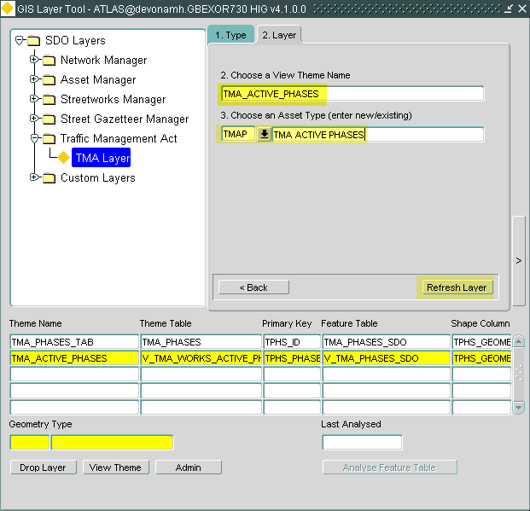

This may take some time but you will eventually get the following message.
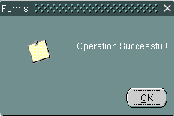

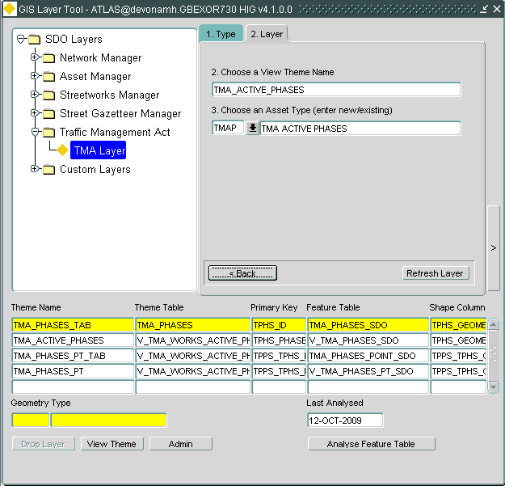
Now repeat the above for Restrictions.
- Make sure the Restrictions check box is checked
- Click on [Get Themes] button. This will populate the bottom grid if it is not populated already.
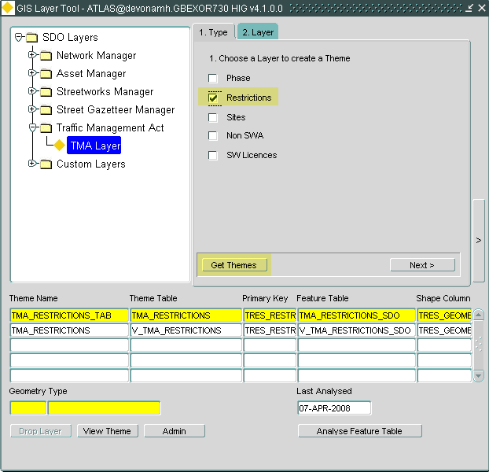

- Make a note of the Theme Name for the feature table V_TMA_RESTRICTIONS_SDO. In this case it is TMA_RESTRICTIONS.
- Click on the next button.
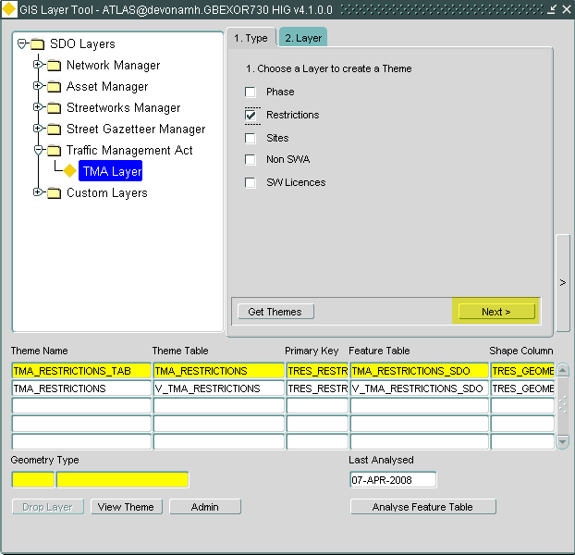

- Put the name of the theme in the top text box (TMA_RESTRICTIONS)
- Set Asset type to TMAR and asset type to TMA RESTRICTIONS. N.B. if this is already set do not change.
- Click on [Refresh Layer] button
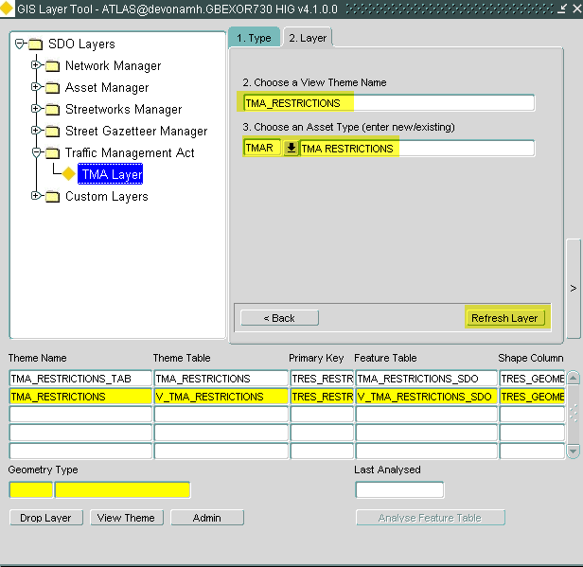

This may take some time but you will eventually get the following message.

And you will see the new themes populated at the bottom of the form.
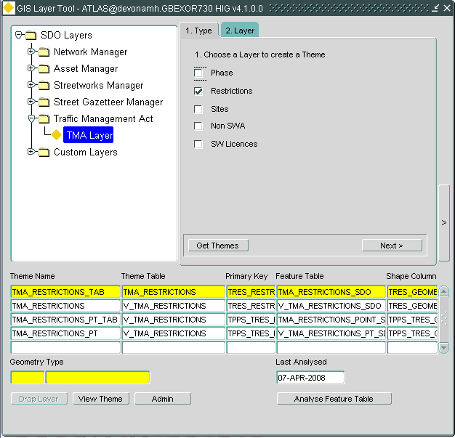

Now repeat the above for SITES.
- Make sure the Site check box is checked
- Click on [Get Themes] button. This will populate the bottom grid if it is not populated already.
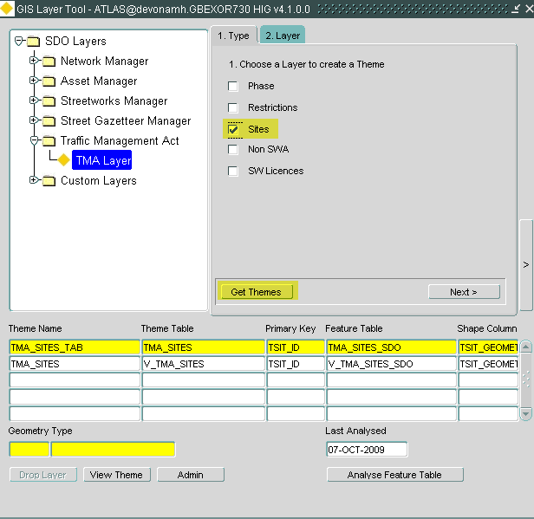

- Make a note of the Theme Name for the feature table V_TMA_SITES_SDO. In this case it is TMA_SITES.
- Click on the next button.
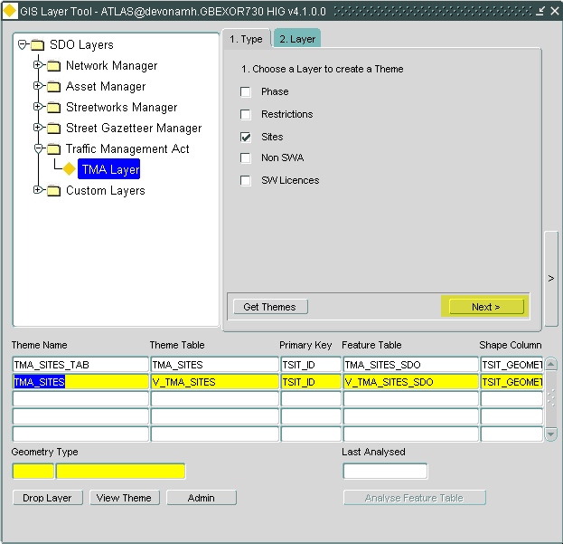

- Put the name of the theme in the top text box (TMA_SITES)
- Set Asset type to TMAS and asset type to TMA SITES. N.B. if this is already set do not change.
- Click on [Refresh Layer] button
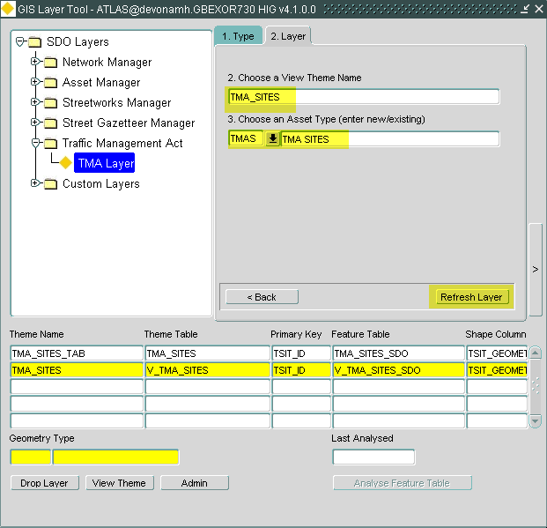

This may take some time but you will eventually get the following message.

And you will see the new themes populated at the bottom of the form.

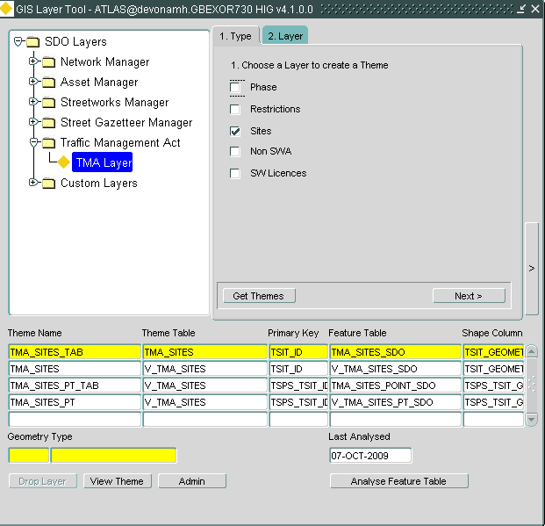
Ignore the rest of the TMA themes as they are not relevant at this release.

Run Script TMA_THEMES_4_1.sql
Check for errors.

Adding Styles & Themes to Map
- Run MapBuilder and load the styles using Tools Import Metadata
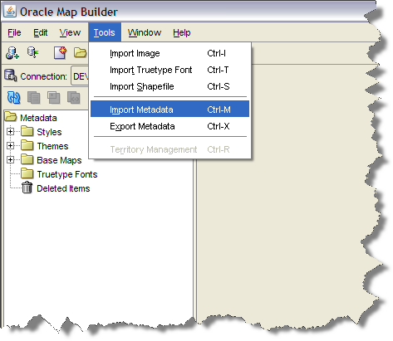
- Click on the file button and navigate to where the file TMA_STYLES_4_1.dat is stored.
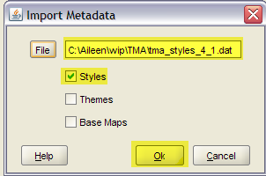
- Make sure only the Styles check box is ticked.
- Click on the [OK] button.
- Find all the Maps being used by the application using the following SQL.
select hop_value MAP_NAME from hig_options where hop_id = 'WEBMAPNAME'
union
select unique HUO_VALUE MAP_NAME from hig_user_Options where HUO_ID = 'WEBMAPNAME';
If there is more than one, discuss with the customer which maps should have the new point TMA themes.
- Open each of the Maps in MapBuilder, by double clicking on their name in the left-hand pane.
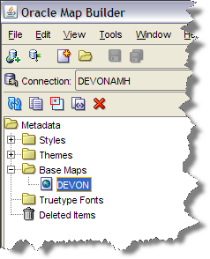
- Scroll down to the bottom of the list of layers until you find the existing TMA Themes.
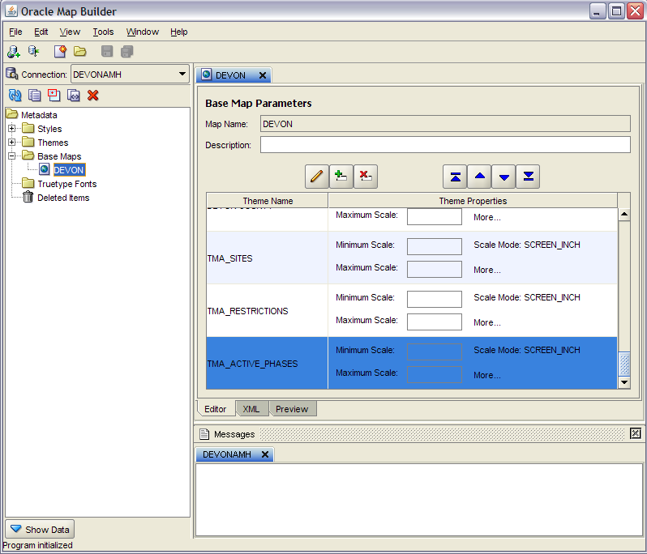
- Add the new point themes as appropriate. I would typically have the point themes after the multi feature type theme.
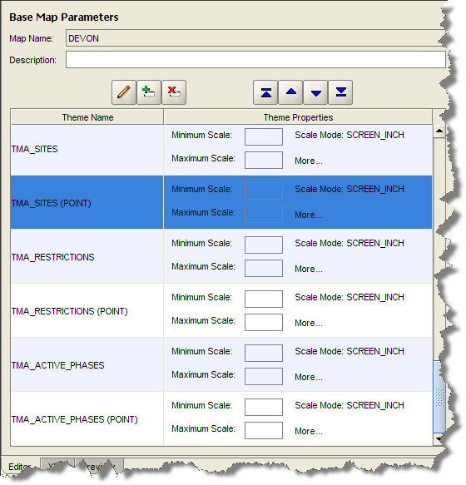
- Save the Map by pressing the save button (or menu option File Save).
- Restart MapViewer
- Restart the application and check the layers appear in the layer control and the map looks OK.

